**Implementation Document**

**Business Understanding**

**Business Objective**

The objective of the entire project is to aid in the reduction of crime within Baltimore. This objective is to be carried out by making use of data science and machine learning techniques. One area that has been marked out for focus is “Crime and Youth”. The objective for this focus is to help reduce crime rates by the youth of Baltimore.

**Assess Situation**

Currently Baltimore has a record high rate of homicide. It has a higher rate of homicide than any other city in America. Baltimore’s rise in homicide and other crimes is being credited to a “Drug Turf-War”.

**Data Mining Goals**

1. Predict the likelihood of a crime being a felony crime based off the offenders age.
2. Predict the likelihood of a crime being a felony crime based off the offenders age and the poverty rating of the neighbourhood the offence was committed in.
3. Predict the most dangerous areas in Baltimore
4. Predict the most dangerous times in Baltimore’s highly populated areas.

**Project Plan**

Using Rapid Miner the datasets that have been gleaned and prepared from various places will be used to make the predictions previously mentioned.

The results of these predictions/ models will be assessed and analysed before being presented in a manner that conveys the finding clearly and correctly.

**Data Understanding**

**Collect Data**

Two datasets (Crime, Incidents) were collected from the BaltimorePD website.

A dataset containing information on the Baltimore neighbourhoods was gleaned from, by using a scraper made from Python using beautiful soup 4.

A dataset was gleaned from Maryland State Commission on Criminal Sentencing Policy by downloading the pdf and using PDFElement to convert the table inside the PDF into a csv file.

**Describe Data**

Explain each dataset

**Explore Data**

ASK GREG??

**Verify Data Quality**

Both the Arrests and Incidents datasets had missing values in a number of their rows. Apart from these missing values the data was relatively acceptable with only a small number of exceptions.

The dataset that was gleaned from , was constructed by the authors and as such was tailor made to suit the project without any faults.

The dataset from MSCCSP outlining charges was constructed by PDFElement and as such was imperfect and had various issues with it.

**Data Preparation**

**Select Data**

State the data to be used for each goal

**Clean Data**

Arrests:

Neighbourhoods:

ChargeDesription: This dataset had to be cleaned substantially. There was several problems and these included merging of two columns that needed to be separated. Extra characters appended to the end of the charge strings. There was also some missing values that had o be removed.

**Construct Data**

The project requires the Arrests dataset to have a ‘Felony’ Boolean column added to it. This is done by comparing the code in the arrests data to the code in the OffenceTable dataset and using the Type column in the OffenceTable a true or false value is determined and added to the Arrests dataset.

The Neighbourhoods dataset had two columns added to it. These were PopulationRank and IncomeRank. These were added through Python by calculating appropriate labels for each neighbourhood based off their density and household income in comparison to the other neighbourhoods.

**Integrate Data**

Not Applicable

**Format Data**

All of the data was formatted as csv files.

**Analysis of Crime and Youth**

**Objective:**

The objective of this section is to analyse and asses the situation in Baltimore with regards to the youth of Baltimore and committing felony crime. The final objective of this section is to provide information gleaned from the work undertaken that will aid in preventing young people from following a life of crime.

**Data:**

The data used for this section is the Arrests data set that has been completed by the addition of the felony Boolean column.

**Modelling Technique:**

The modelling technique chosen here is Naïve Bayes. This was chosen as only one column is being used to predict the outcome of felony or misdemeanour. Naïve Bayes will be able to do this task with extreme ease.

**Results:**

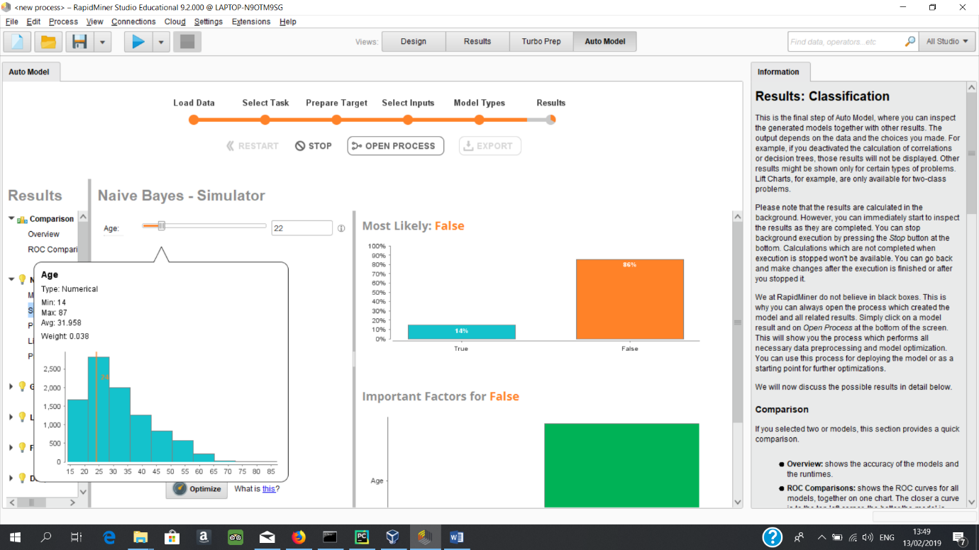

This Screenshot demonstrates a histogram that shows the frequency of crimes based on the ages of the offender.

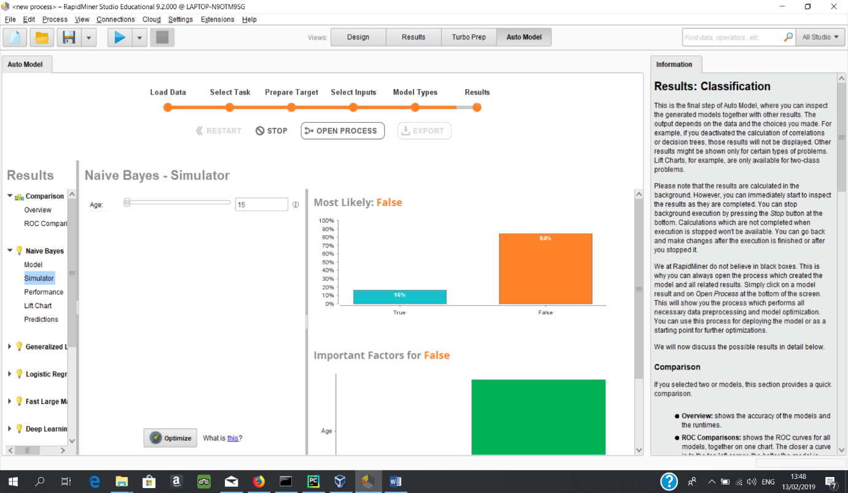This screenshot shows the results of Naïve Bayes prediction of the probability of a crime being a felony crime if the age of the offender is 15. The result is 16% chance of the crime being a felony crime.

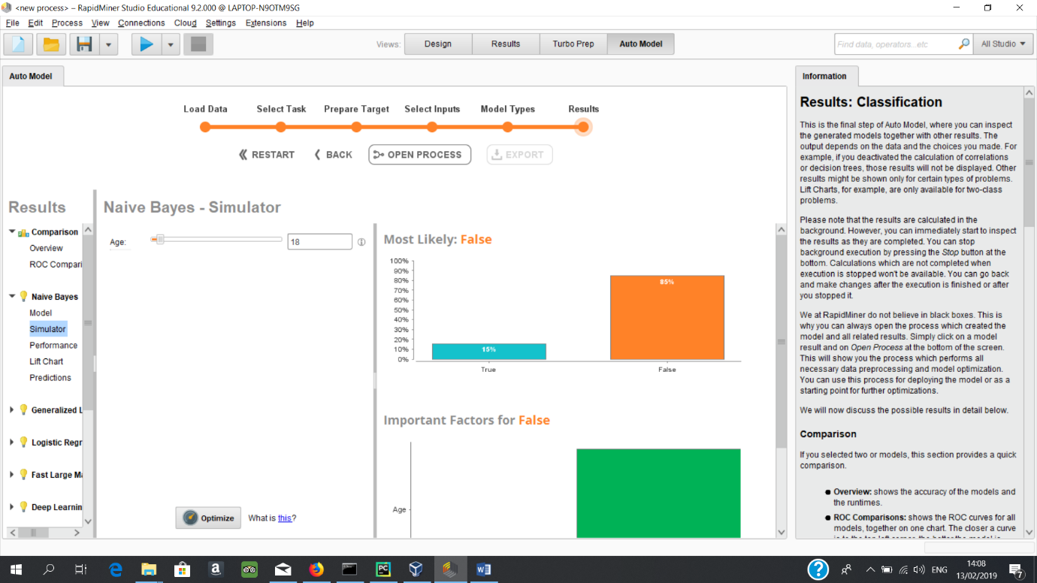

This screenshot shows the results of Naïve Bayes prediction of the probability of a crime being a felony crime if the age of the offender is 18. The result is 15% chance of the crime

being a felony crime.

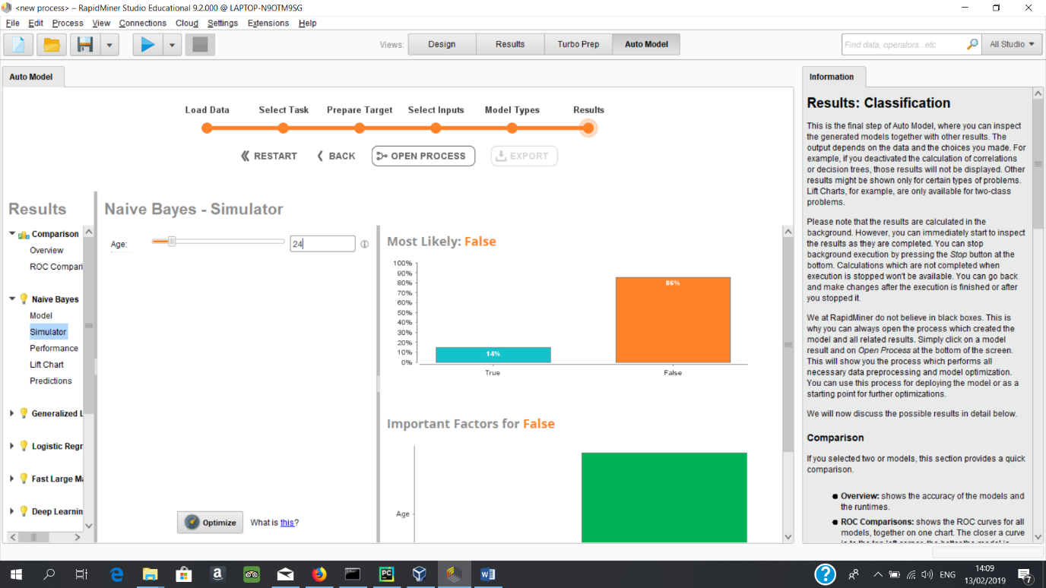

This screenshot shows the results of Naïve Bayes prediction of the probability of a crime being a felony crime if the age of the offender is 24. The result is 14% chance of the crime

being a felony crime.

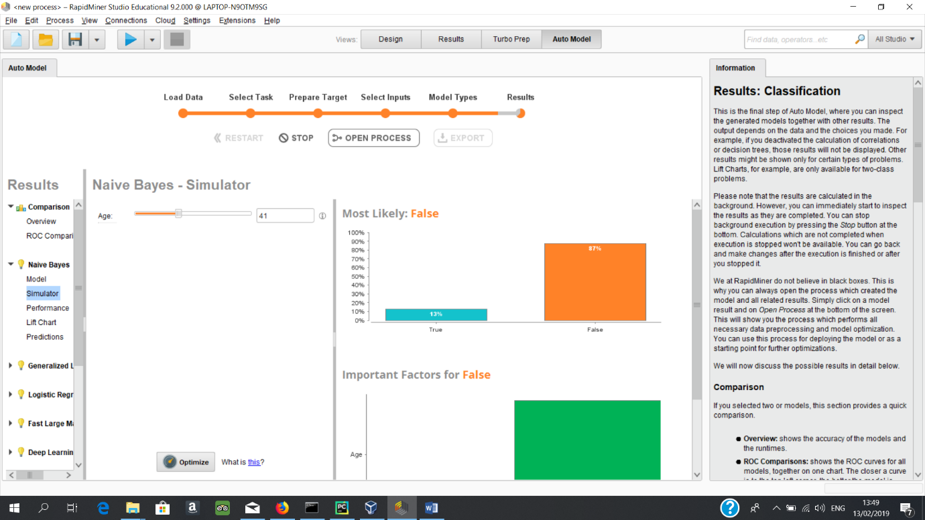

This screenshot shows the results of Naïve Bayes prediction of the probability of a crime being a felony crime if the age of the offender is 41. The result is 15% chance of the crime

being a felony crime.

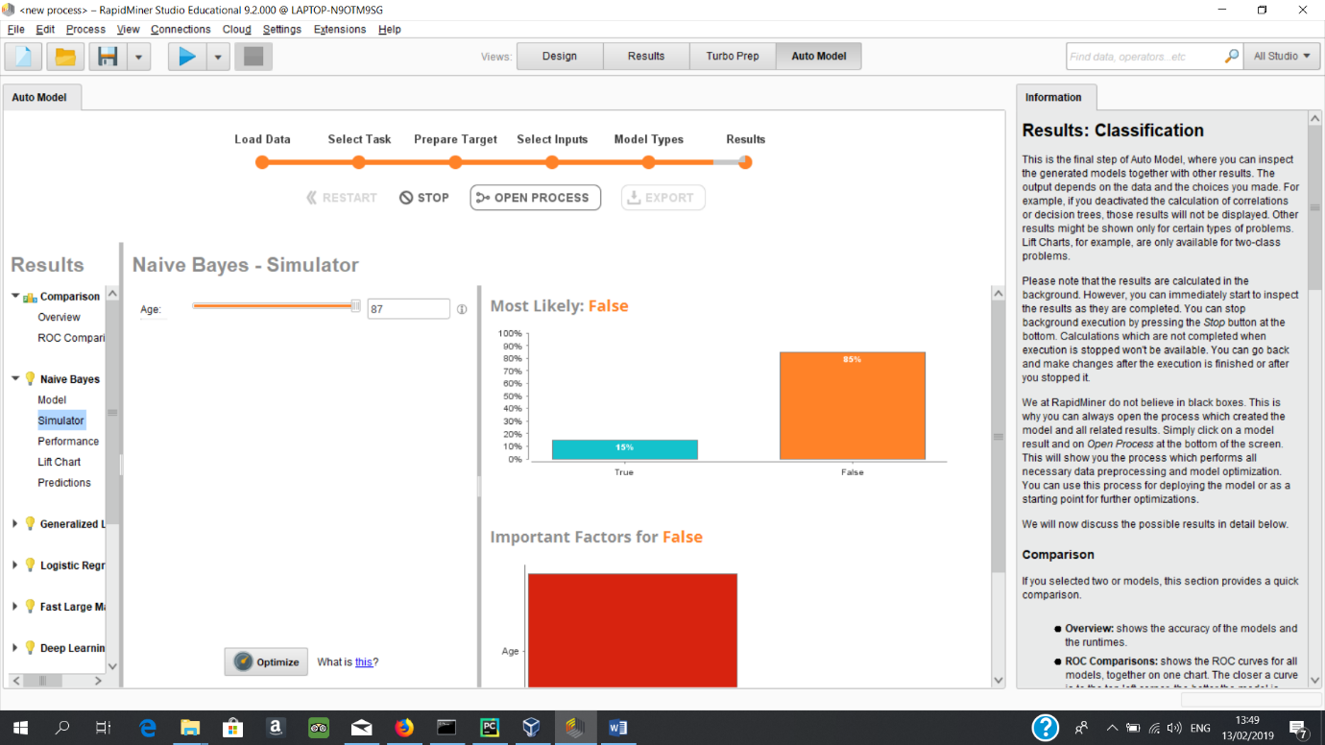

This screenshot shows the results of Naïve Bayes prediction of the probability of a crime being a felony crime if the age of the offender is 87. The result is 16% chance of the crime

being a felony crime.

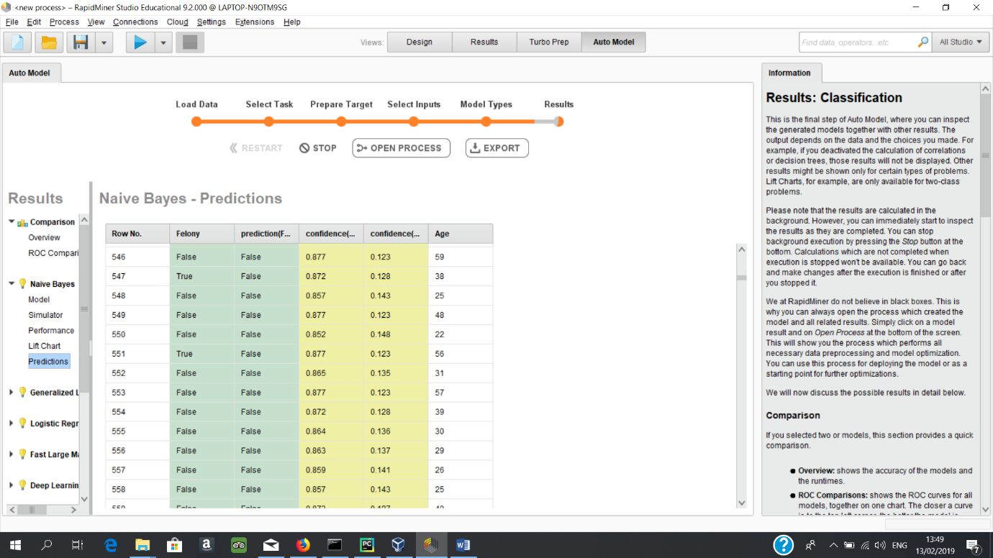

This is a screenshot of a snippet of predictions made.

**Assessment:**

The results for the likelihood of offences being a felony based off age begin at the age of 15. Here the result is a 16% chance of a felony crime. This statistic stays static until 18 when it becomes 15% and the next change is at 24 where the result becomes 14%. 14% is the lowest the result gets to and actually begins to rise again at 41 to 15% and rises again to 16% at 78.

The histogram of crimes does not support these findings as the histogram suggests 20 to 28 year old are committing far more crime and even 28 to 35 year olds are committing more crime than people under 20.

Combining both results suggests that the reason for the high rate of felony crimes in youth is due to a lack of arrests for misdemeanour crimes when they are committed by people under 20. This also rings through to the elderly as people over 78 have the same statistic.

The model was calculated to have an 86% accuracy.

**Recommendations:**

A possible solution to preventing youth offenders from following a life of crime or to prevent them from getting a long term jail sentence in their early 20’s could be to crack down on misdemeanour offences by youth’s. What this means is instead of the perceived light treatment of youths who commit misdemeanour as suggested by the datasets, the police should begin to arrest youths committing misdemeanours more vigorously. This would increase the number of arrests of youths but could instil in these youths that any crime they commit will be punished and would in turn deter these very youths from committing more serious crimes. Not only could this protect the public but could also protect the youths themselves.

**Further Analysis of Crime and Youth in Low Income Areas**

**Objective:**

The objective of this section is to analyse and assess the effect that only analysing low income areas has on the results of the previous section “Analysis of Crime and Youth”. The final objective of this section is to provide information gleaned from the work undertaken that will aid in preventing young people from following a life of crime.

**Data:**

The data used for this section is the LowIncomeArrests data set that has been completed by referencing the NeighbourhoodRanker dataset and thus removing any arrests from the LowIncomeArrests dataset that are not located in low income neighbourhoods.

**Modelling Technique:**

The modelling technique chosen here is Naïve Bayes. This was chosen as only one column is being used to predict the outcome of felony or misdemeanour. Naïve Bayes will be able to do this task with extreme ease.

**Results:** 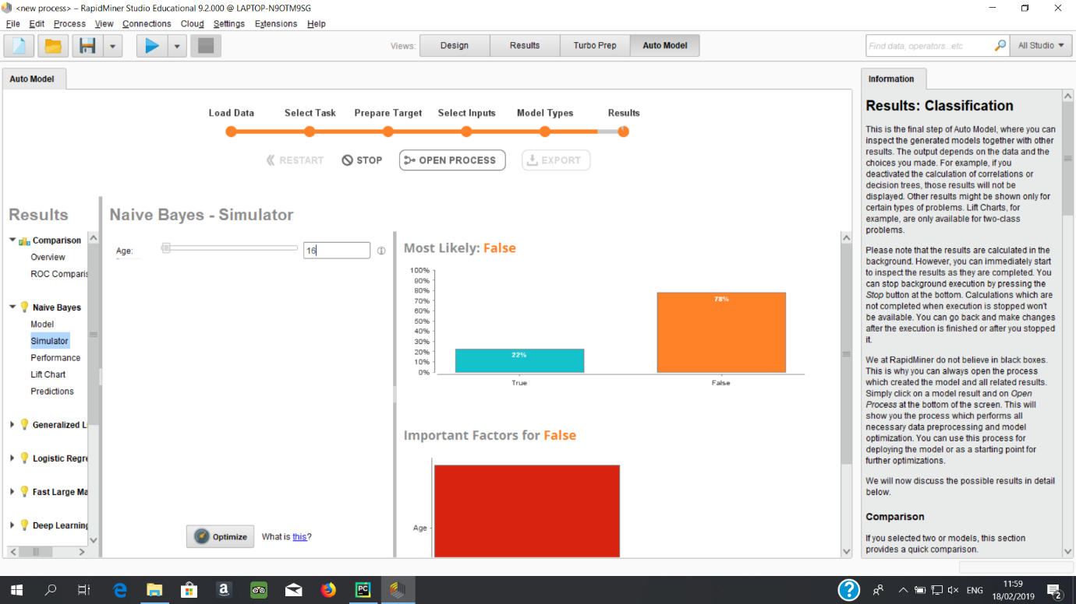

This screenshot shows the results of Naïve Bayes prediction of the probability of a crime being a felony crime if the age of the offender is 16. The result is 22% chance of the crime

being a felony crime.

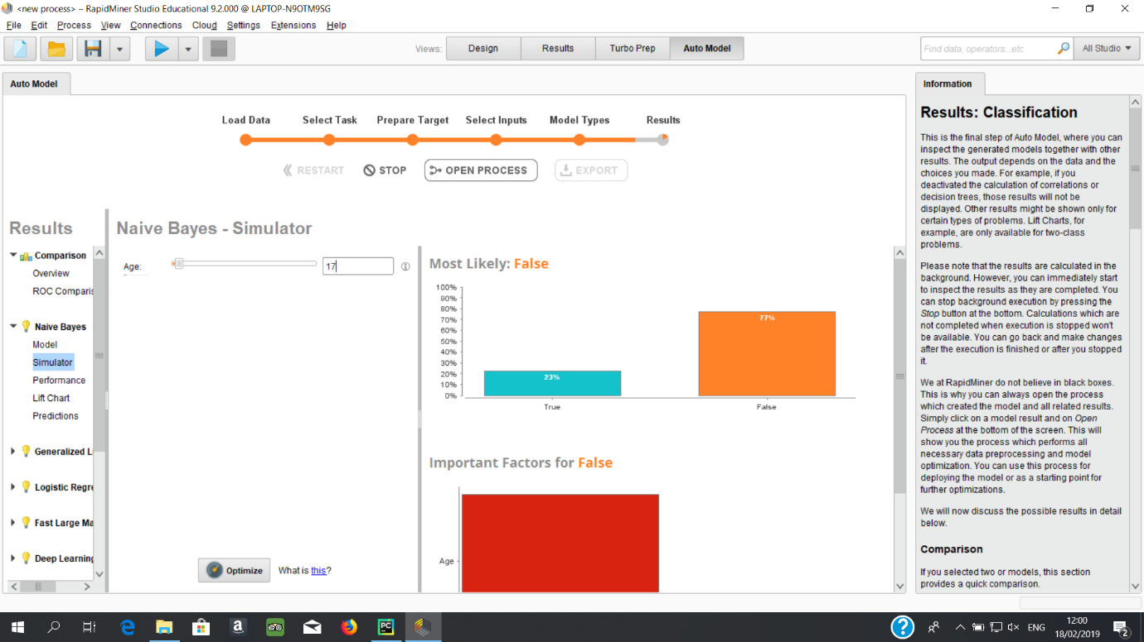

This screenshot shows the results of Naïve Bayes prediction of the probability of a crime being a felony crime if the age of the offender is 17. The result is 23% chance of the crime

being a felony crime. 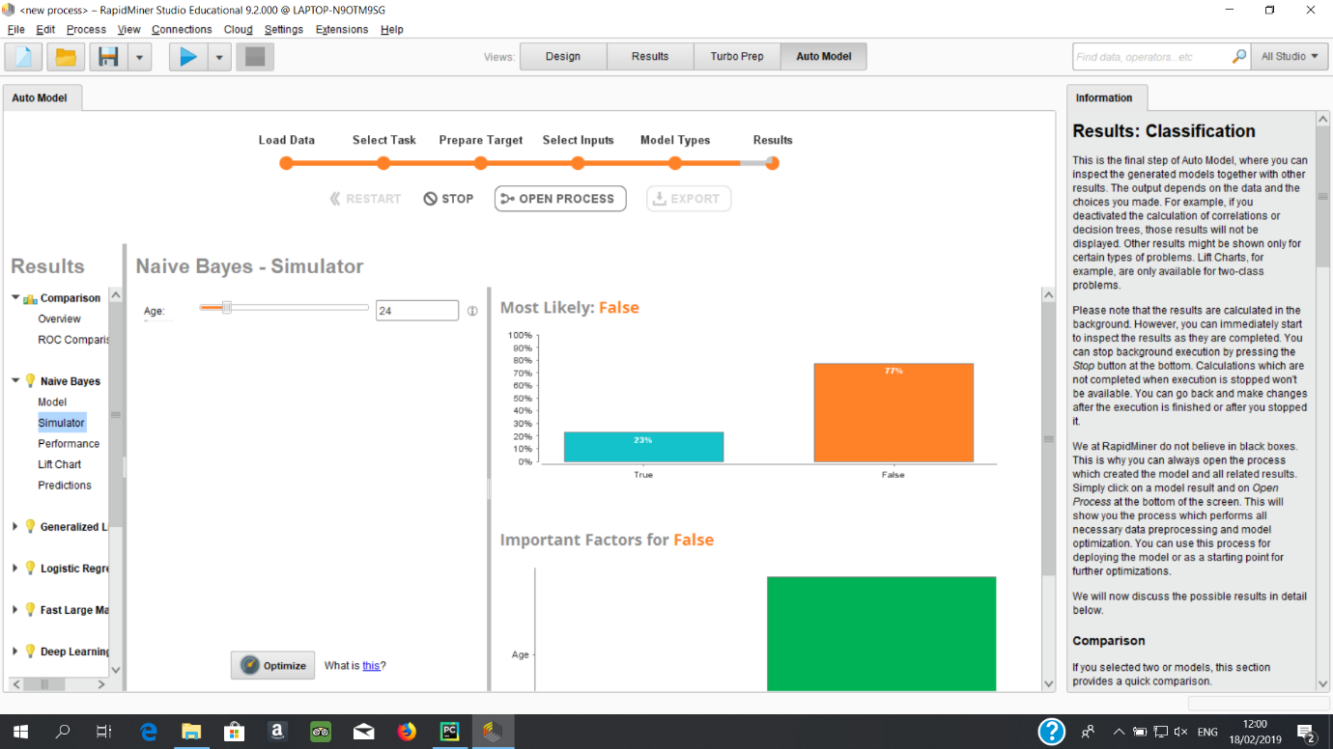

This screenshot shows the results of Naïve Bayes prediction of the probability of a crime being a felony crime if the age of the offender is 24. The result is 23% chance of the crime

being a felony crime.

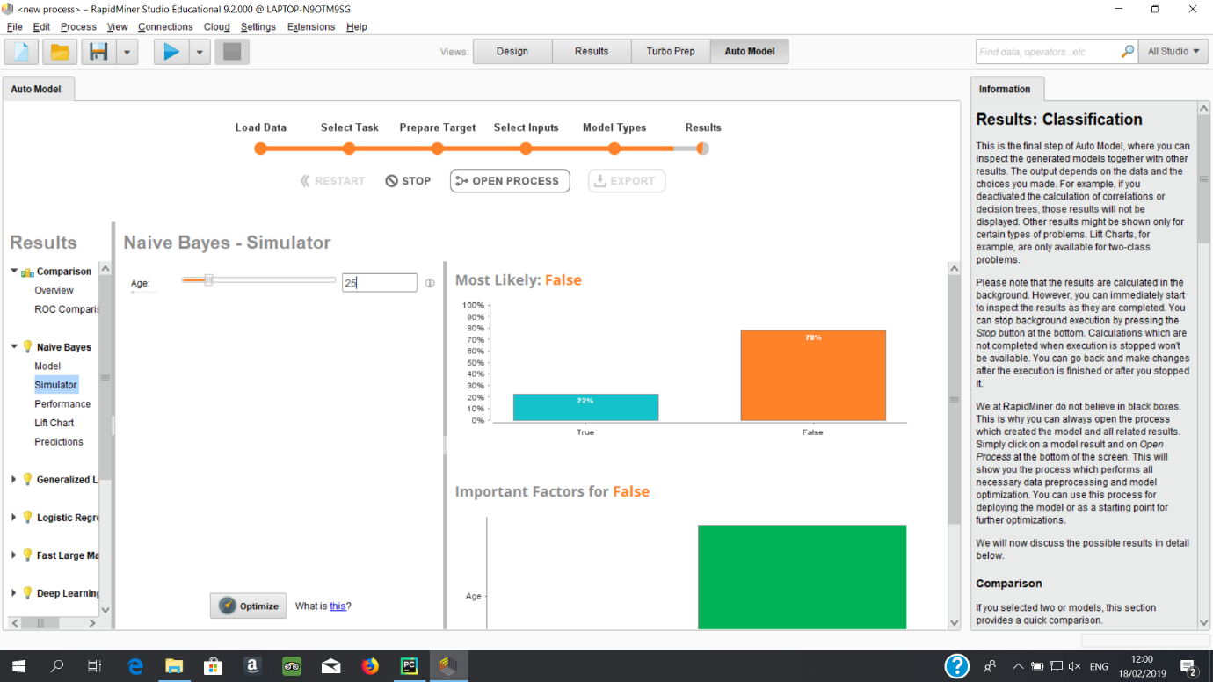

This screenshot shows the results of Naïve Bayes prediction of the probability of a crime being a felony crime if the age of the offender is 25. The result is 22% chance of the crime

being a felony crime. 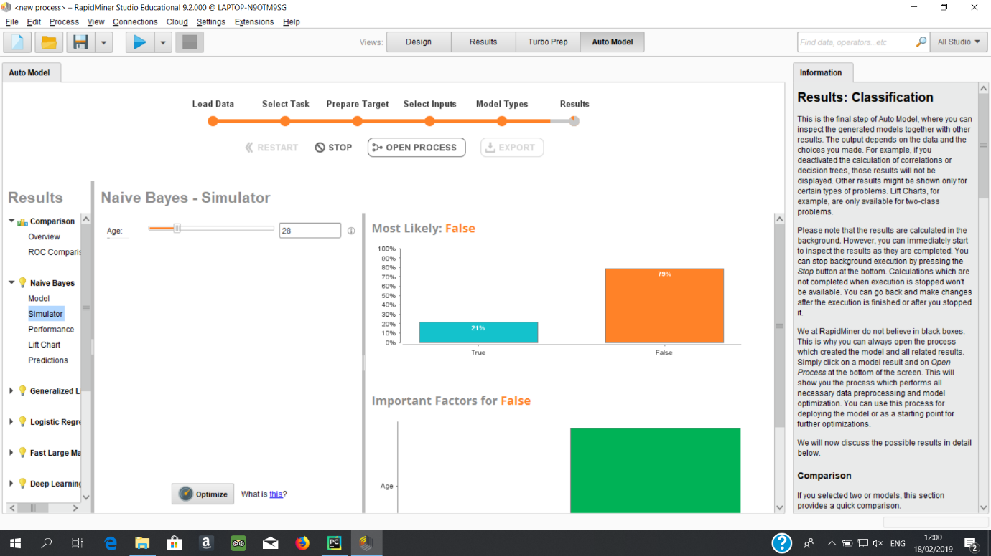

This screenshot shows the results of Naïve Bayes prediction of the probability of a crime being a felony crime if the age of the offender is 28. The result is 21% chance of the crime

being a felony crime.

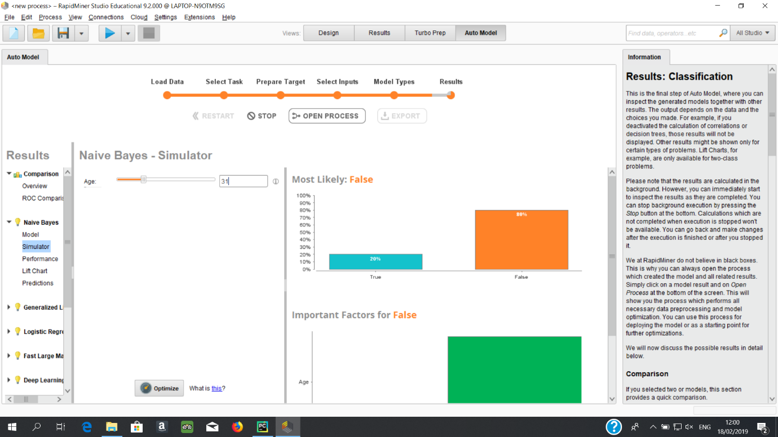

This screenshot shows the results of Naïve Bayes prediction of the probability of a crime being a felony crime if the age of the offender is 31. The result is 20% chance of the crime

being a felony crime. 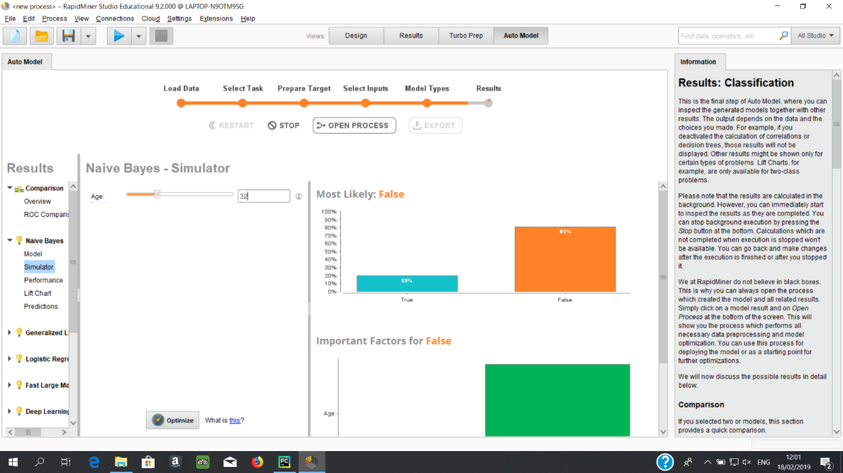

This screenshot shows the results of Naïve Bayes prediction of the probability of a crime being a felony crime if the age of the offender is 32. The result is 19% chance of the crime

being a felony crime.

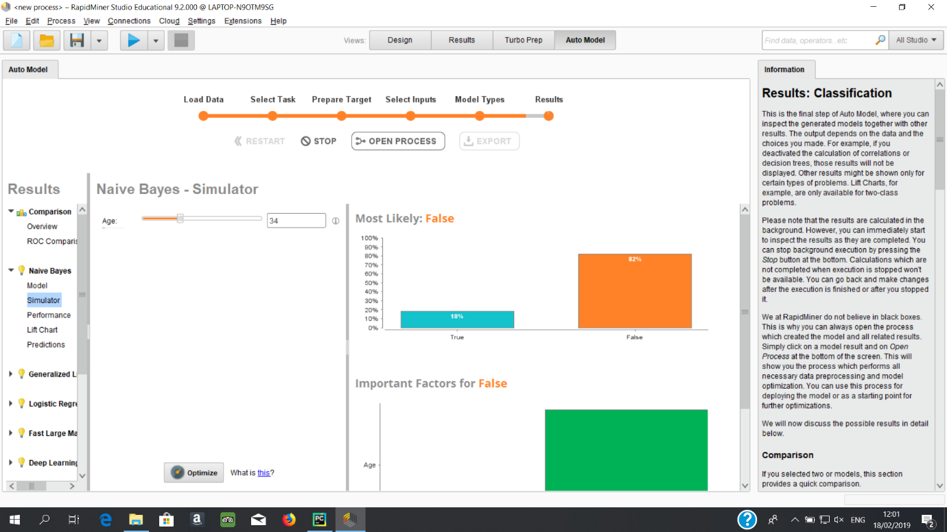

This screenshot shows the results of Naïve Bayes prediction of the probability of a crime being a felony crime if the age of the offender is 34. The result is 18% chance of the crime

being a felony crime. 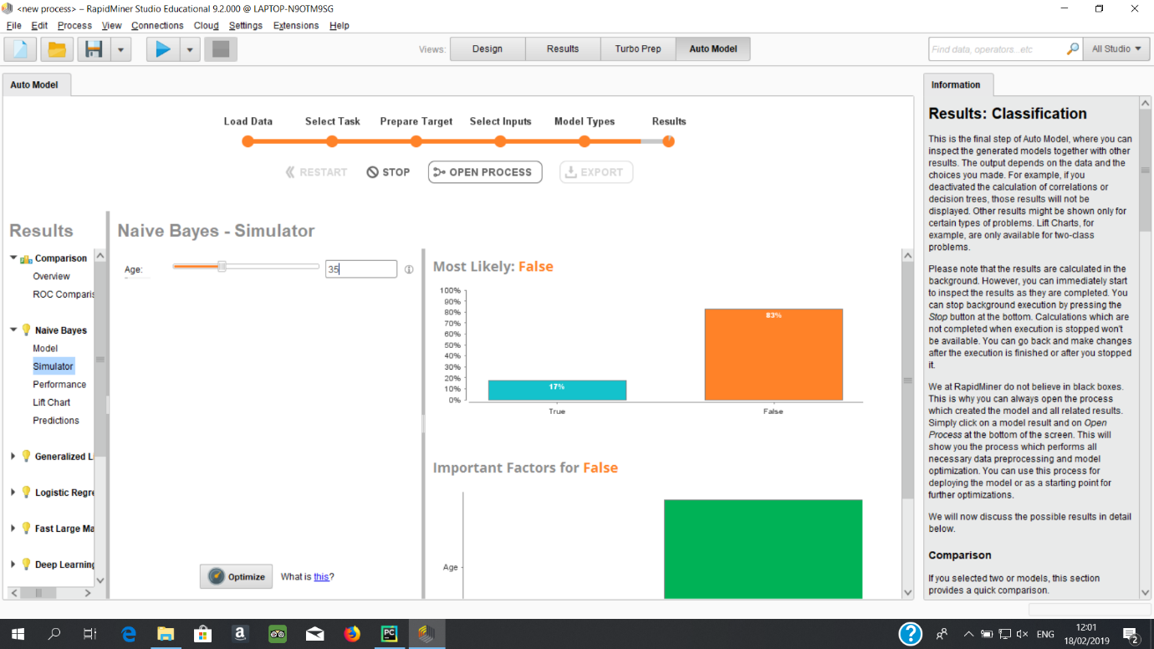 This screenshot shows the results of Naïve Bayes prediction of the probability of a crime being a felony crime if the age of the offender is 35. The result is 17% chance of the crime

being a felony crime.

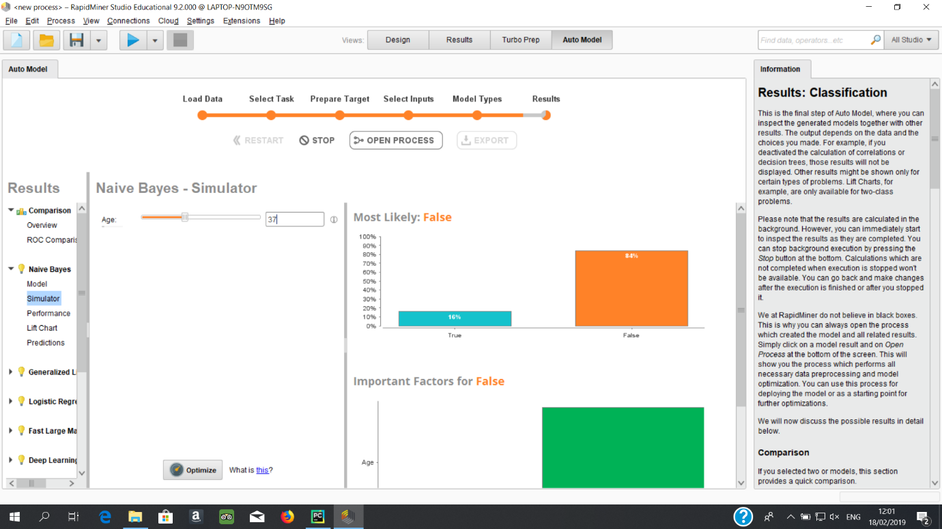

This screenshot shows the results of Naïve Bayes prediction of the probability of a crime being a felony crime if the age of the offender is 37. The result is 16% chance of the crime

being a felony crime.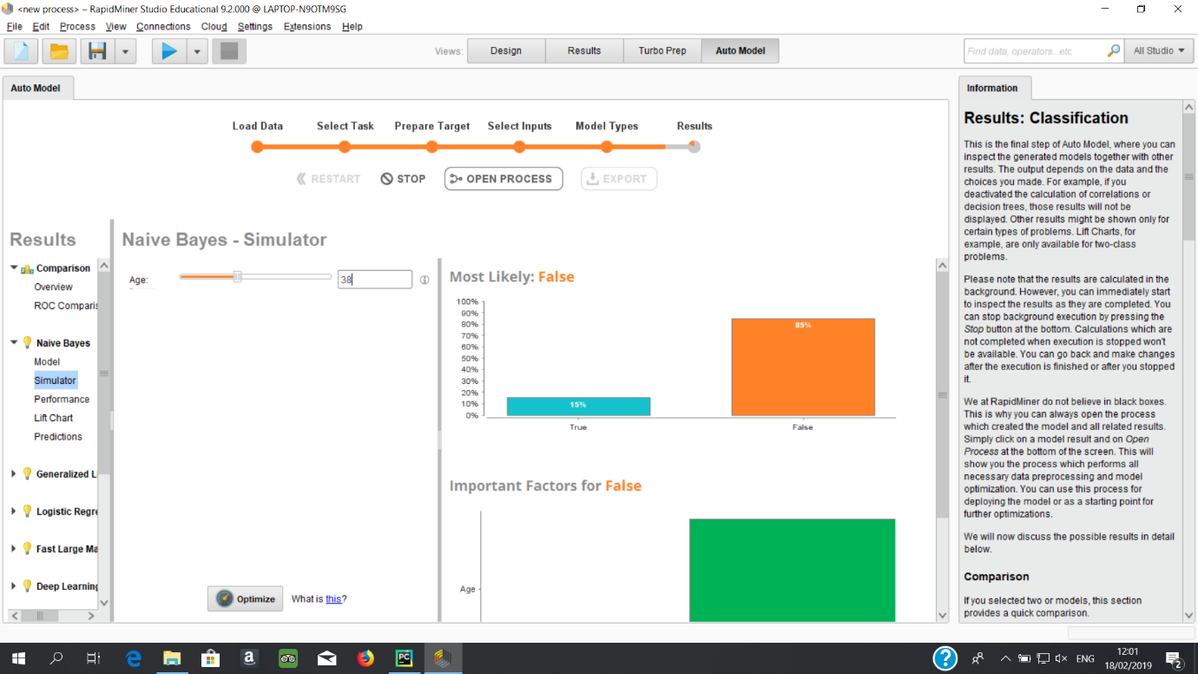 This screenshot shows the results of Naïve Bayes prediction of the probability of a crime being a felony crime if the age of the offender is 38. The result is 15% chance of the crime

being a felony crime.

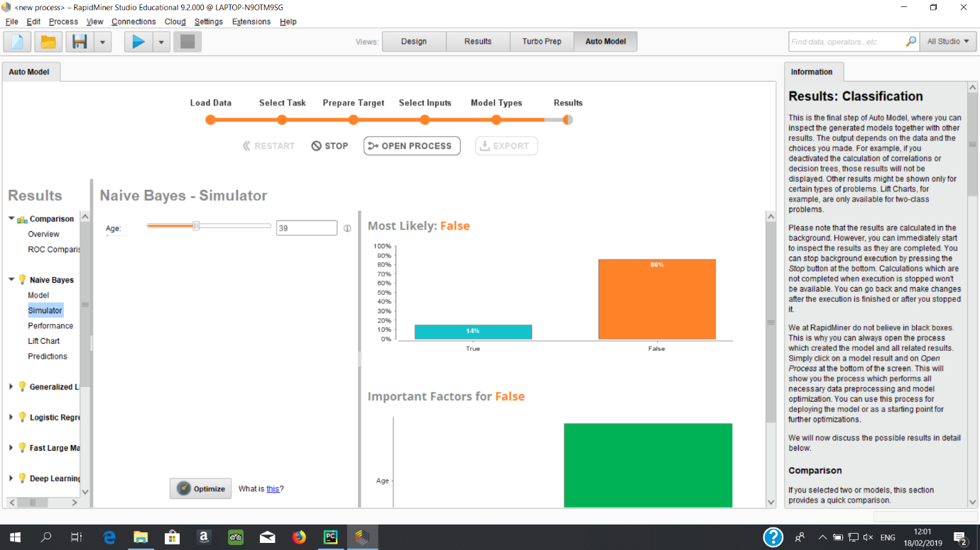 This screenshot shows the results of Naïve Bayes prediction of the probability of a crime being a felony crime if the age of the offender is 39. The result is 14% chance of the crime

being a felony crime. 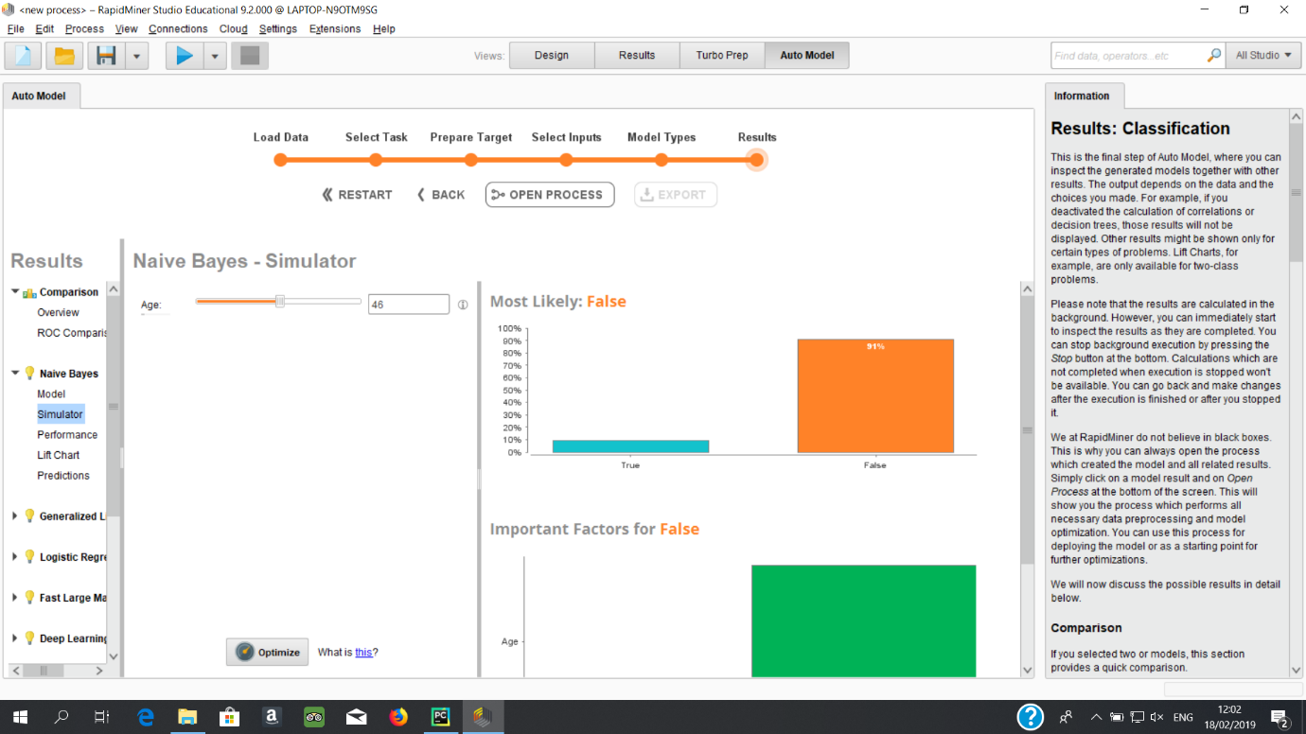 This screenshot shows the results of Naïve Bayes prediction of the probability of a crime being a felony crime if the age of the offender is 46. The result is 9% chance of the crime

being a felony crime.

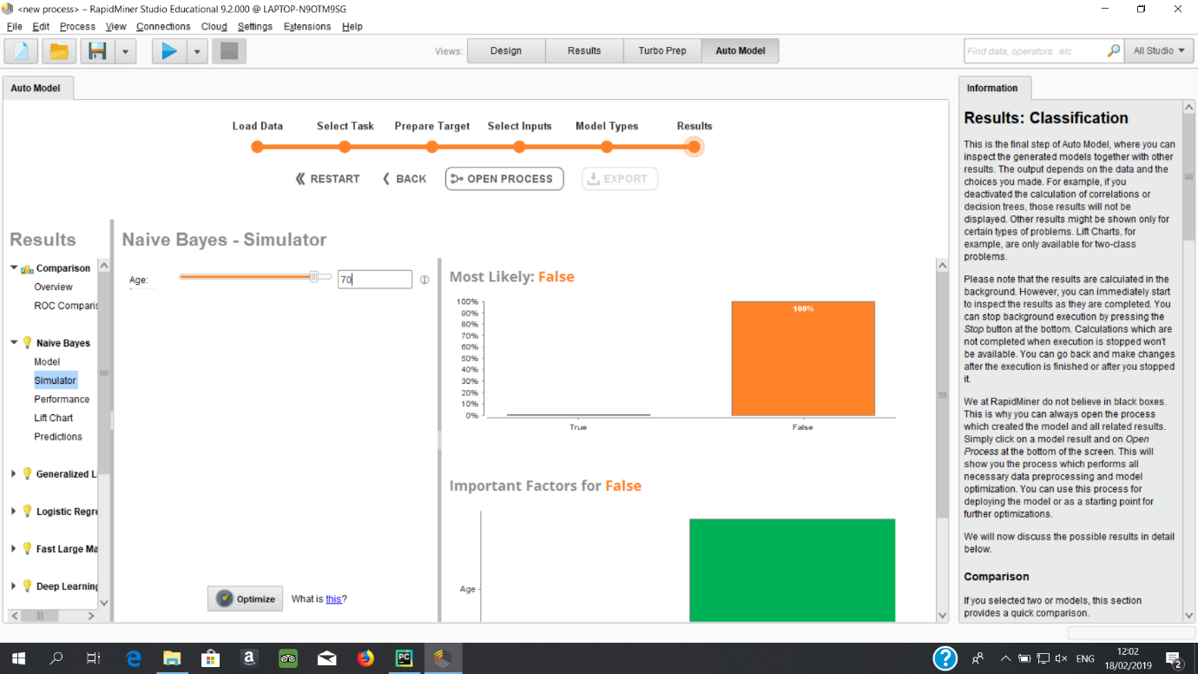 This screenshot shows the results of Naïve Bayes prediction of the probability of a crime being a felony crime if the age of the offender is 70. The result is 0% chance of the crime

being a felony crime.

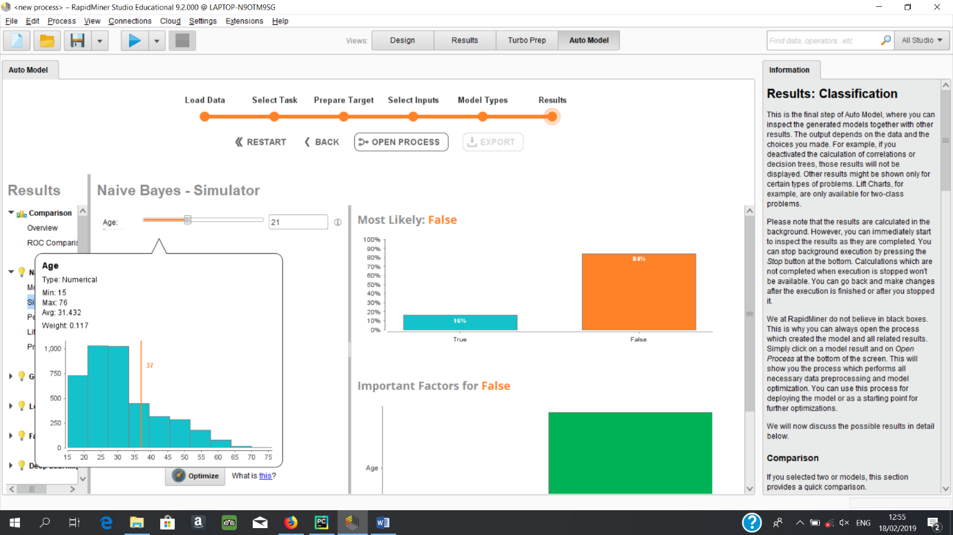 This Screenshot demonstrate a histogram that shows the frequency of crimes based on the ages of the offender.

**Assessment:**

As with the previous results the results for the likelihood of offences being a felony based off age in low income areas begin at the age of 15. Here the result is a 22% chance of a felony crime. This statistic stays static until 16. At 17 it becomes 23% and the next change is at 25 where the result becomes 22%. The result from here until the last result continues to fall. At 32 the probability of a person committing a felony crime falls to 19% and at 46 the probability falls below 10% to 9%. People over the age of 70 in a low income are have a 0% chance of committing felony crimes.

The histogram shows that crime rate in general increase as people become 21 and despite a lower rate of felony crimes, 27 to 32 year olds commit the same amount of crimes as 21 to 27 year olds. There is an amazing drop in crimes rate from the age of 32 upward.

These results differ substantially from the previous results. The very high change in the probability of felony crime is startling. Almost 1 in 4 crimes committed by 17 to 24 year old is a felony crime.

The model was calculated to have an 86% accuracy.

**Recommendations:**

Analysing the results seems to show a worrying result that most felony crimes are actually committed by youths. This suggests that in order to prevent this trend from occurring youths of a younger age than the ages specified in the results should be targeted. Therefore it is the children that should be targeted to try and prevent them from following a life of crime. Children under the age of 15 should be firstly educated about committing serious crimes and the adverse effect it has on their future. A program should be started to ensure that these children have access to opportunities that children from higher income areas have access to. For example tutoring services that will allow these children to compete on a level playing field for academic scholarships. Furthermore a more drastic and maybe controversial recommendation is to actively seek to remove children under 10 years of age from these areas whose parents have previous felony convictions and place these children into the care of the state.

**Analyse the Danger of Each Hour in Baltimore**

**Objective:**

The objective of this section is to analyse and assess the danger level of the hours of the day in Baltimore. The final objective of this section is to provide information gleaned from the work undertaken that will prevent innocent people being victims of crime and to help the public feel safer in Baltimore.

**Data:**

The data used for this section is the DateAndHoursArrests data set that has been completed by analysing the time column of each row and extracting the hour of day the arrest was made at.

**Modelling Technique:**

The modelling technique chosen here is Naïve Bayes. This was chosen as only one column is being used to predict the outcome of felony or misdemeanour. Naïve Bayes will be able to do this task with extreme ease.

**Results:**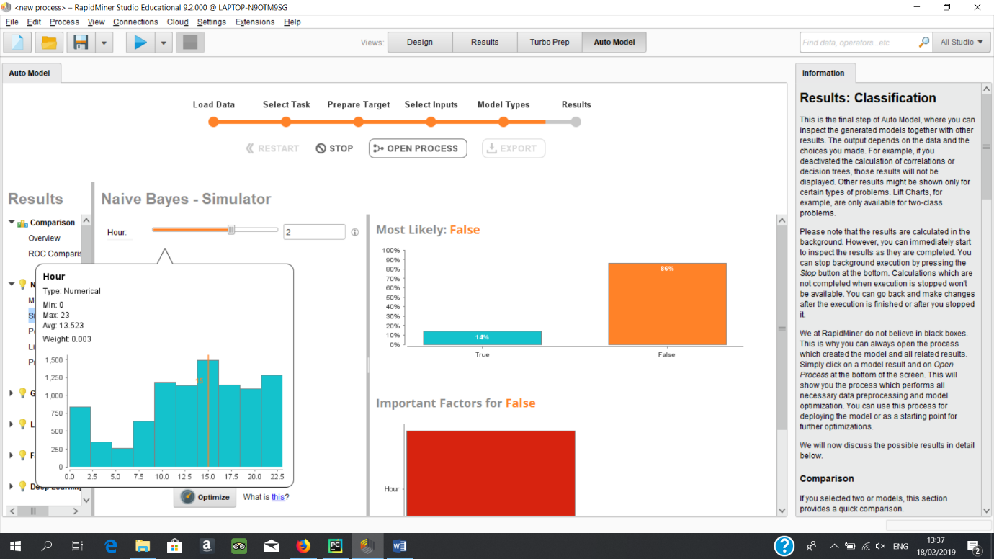 This Screenshot demonstrates a histogram that shows the frequency of crimes based on the hour of the day.

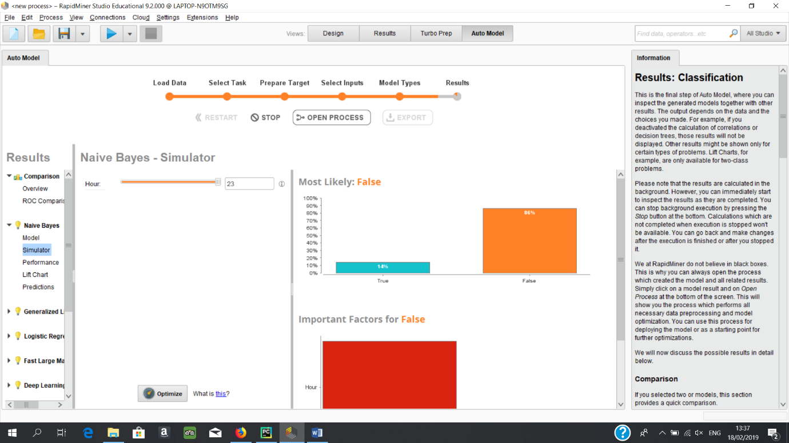 This screenshot shows the results of Naïve Bayes prediction of the probability of a crime being a felony crime if the time of day is 11pm. The result is 14% chance of the crime

being a felony crime.

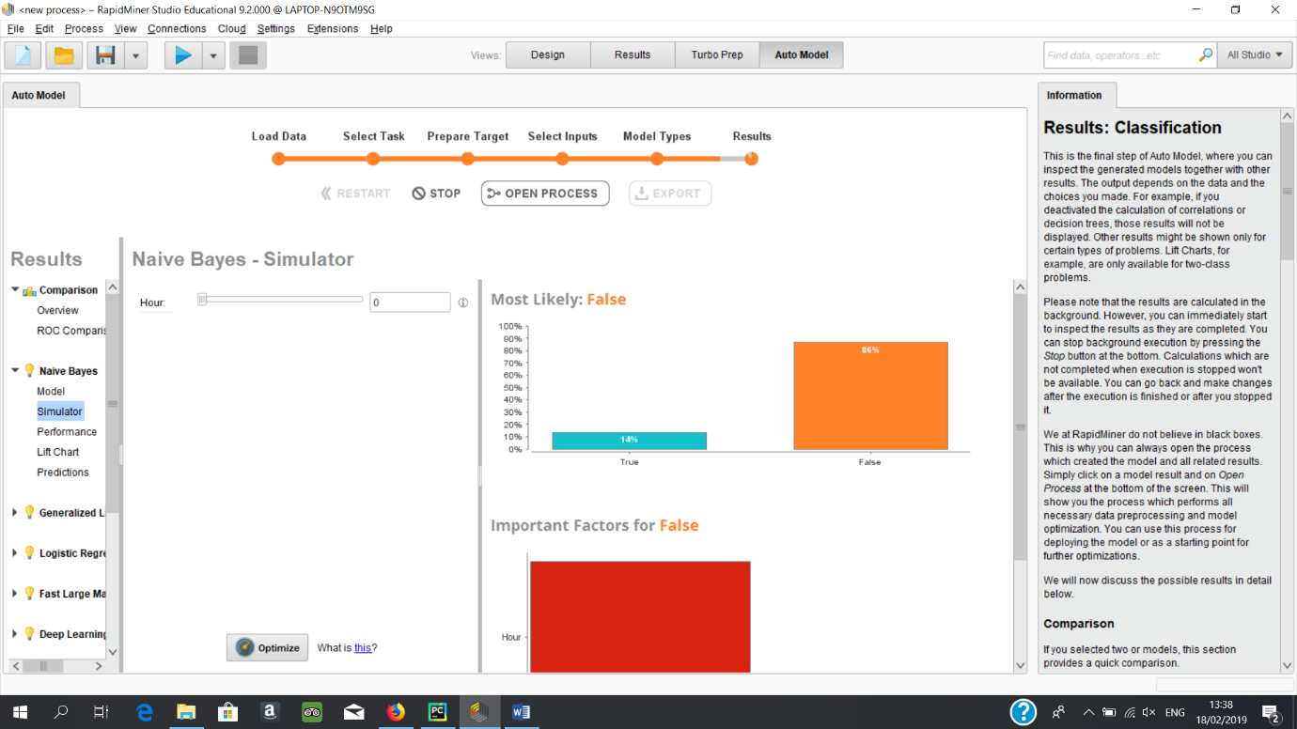

This screenshot shows the results of Naïve Bayes prediction of the probability of a crime being a felony crime if the time of day is 0am. The result is 14% chance of the crime

being a felony crime.

**Assessment:**

Amazingly at no hour of the day does the probability of a crime being a felony crime increase from 14%. For this reason only two screenshots were show in results. This result is disappointing as it was hoped that an analysis could be used to help people avoid violent crimes which are predominantly felony crimes.

While felony crimes cannot provide a significant amount of information the histogram detailing all crimes shows that the period of 1pm to 4 pm has the highest rate of crime throughout the day. This is followed by 9pm to 11pm.

The model was calculated to have an 81% accuracy.

**Recommendations:**

Not many recommendations can be made due to the low amount of viable information gleaned from the data. The only recommendations that the author will make to the public is to be vigilant between the hours of 1pm to 4pm and 9pm to 11pm. It is also recommended that the police department increase the amount of police they have on duty at these times.

It is also worth noting that these times are based off of all the days of the week. Therefore these results might be a little skewed.

**Analyse the Danger of Each Hour in Densely Populated Areas in Baltimore**

**Objective:**

The objective of this section is to analyse and assess the danger level of the hours of the day in Baltimore focusing on densely populated areas. The final objective of this section is to provide information gleaned from the work undertaken that will prevent innocent people being victims of crime and to help the public feel safer in Baltimore’s densely populated areas.

**Data:**

The data used for this section is the HighDensityArrests data set that has been completed by referencing the NeighbourhoodRanker dataset and thus removing any arrests from the BaltimoreNeighbourhoodsComplete dataset that are not located in high density neighbourhoods.

**Modelling Technique:**

The modelling technique chosen here is Naïve Bayes. This was chosen as only one column is being used to predict the outcome of felony or misdemeanour. Naïve Bayes will be able to do this task with extreme ease.

**Results:** 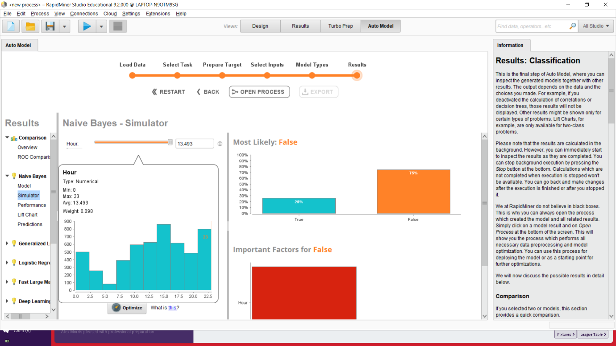

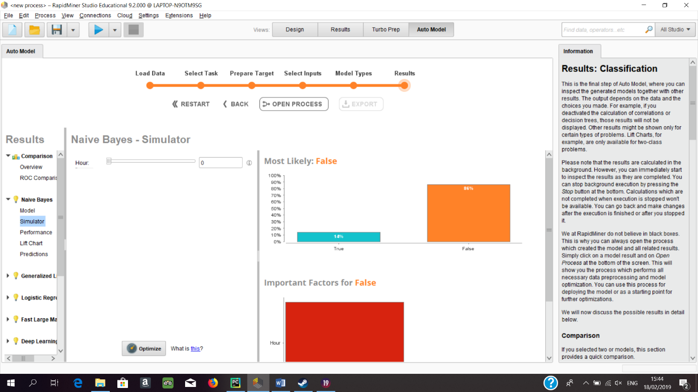 This screenshot shows the results of Naïve Bayes prediction of the probability of a crime being a felony crime if the time of day is 0am. The result is 14% chance of the crime

being a felony crime.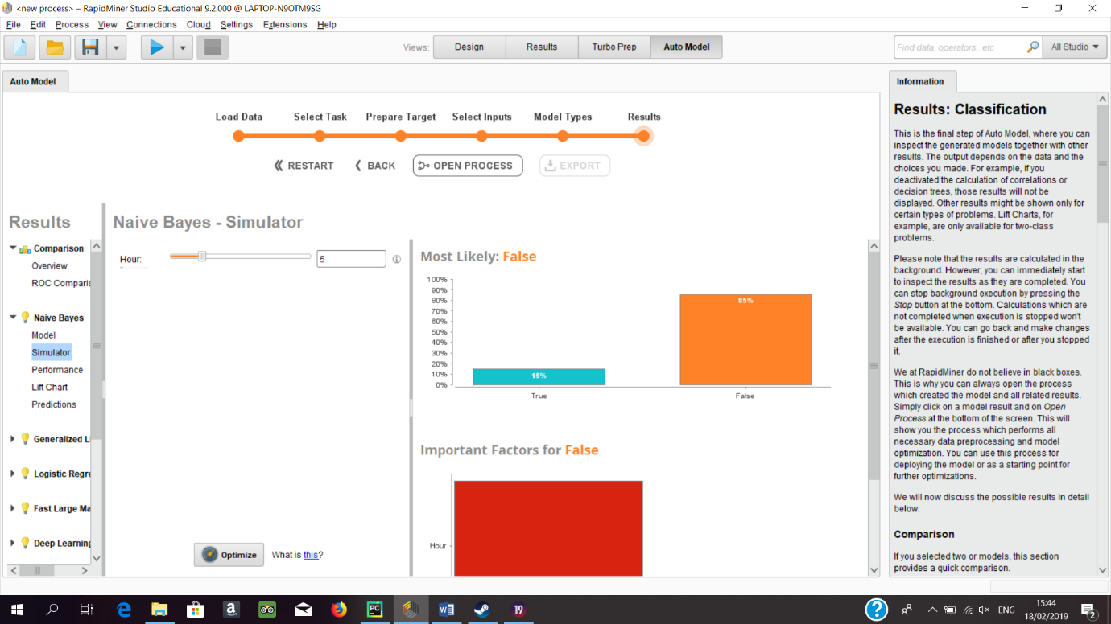 This screenshot shows the results of Naïve Bayes prediction of the probability of a crime being a felony crime if the time of day is 5am. The result is 15% chance of the crime

being a felony crime.

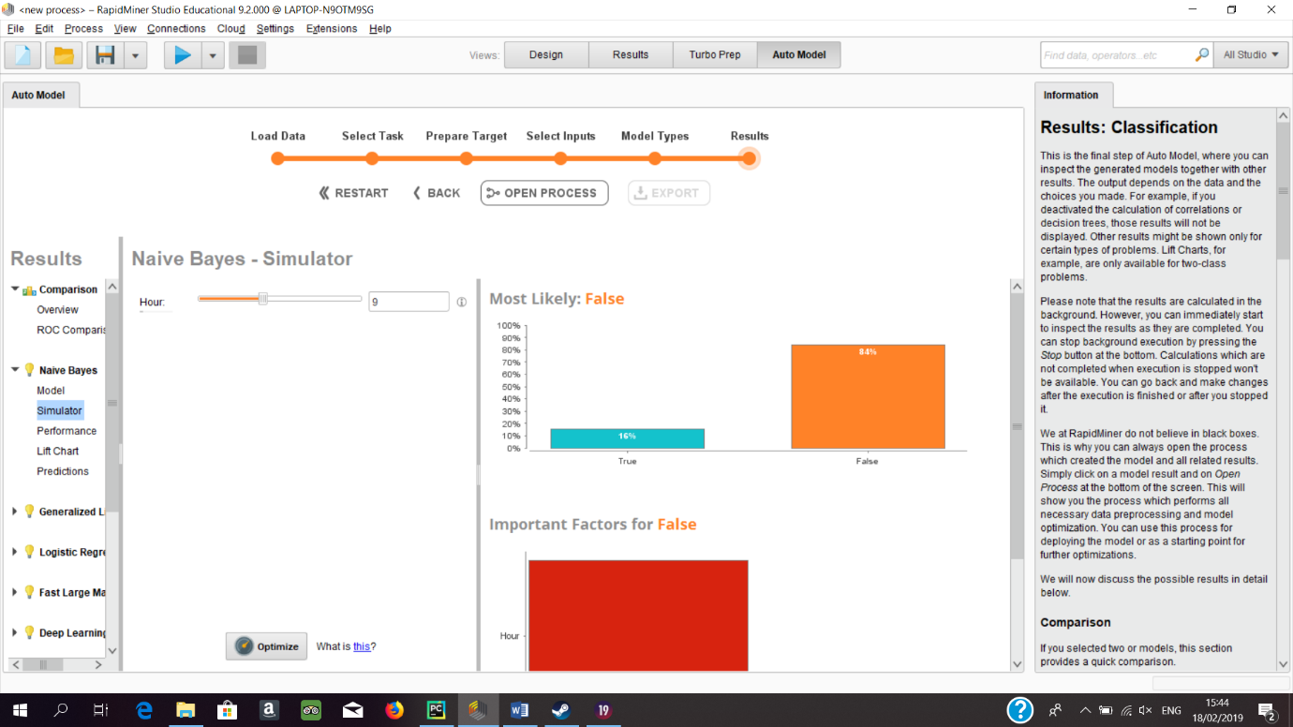 This screenshot shows the results of Naïve Bayes prediction of the probability of a crime being a felony crime if the time of day is 9am. The result is 16% chance of the crime

being a felony crime.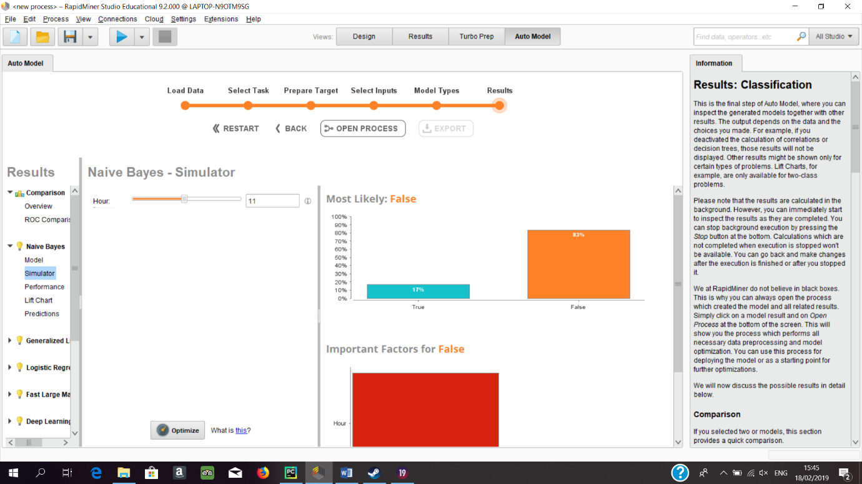 This screenshot shows the results of Naïve Bayes prediction of the probability of a crime being a felony crime if the time of day is 11am. The result is 17% chance of the crime

being a felony crime.

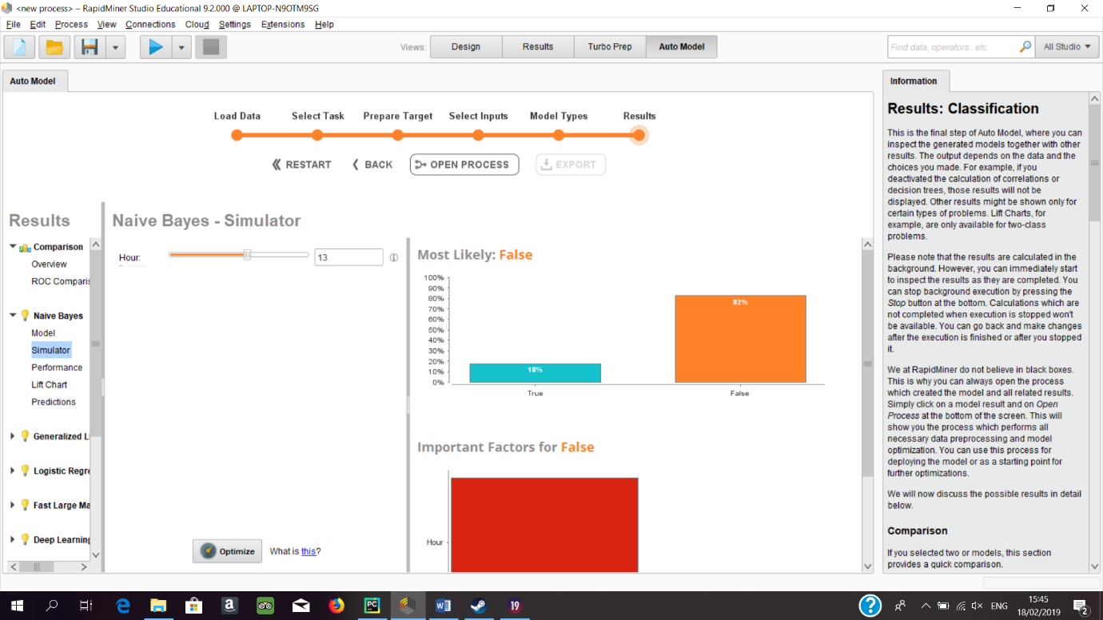 This screenshot shows the results of Naïve Bayes prediction of the probability of a crime being a felony crime if the time of day is 1pm. The result is 18% chance of the crime

being a felony crime.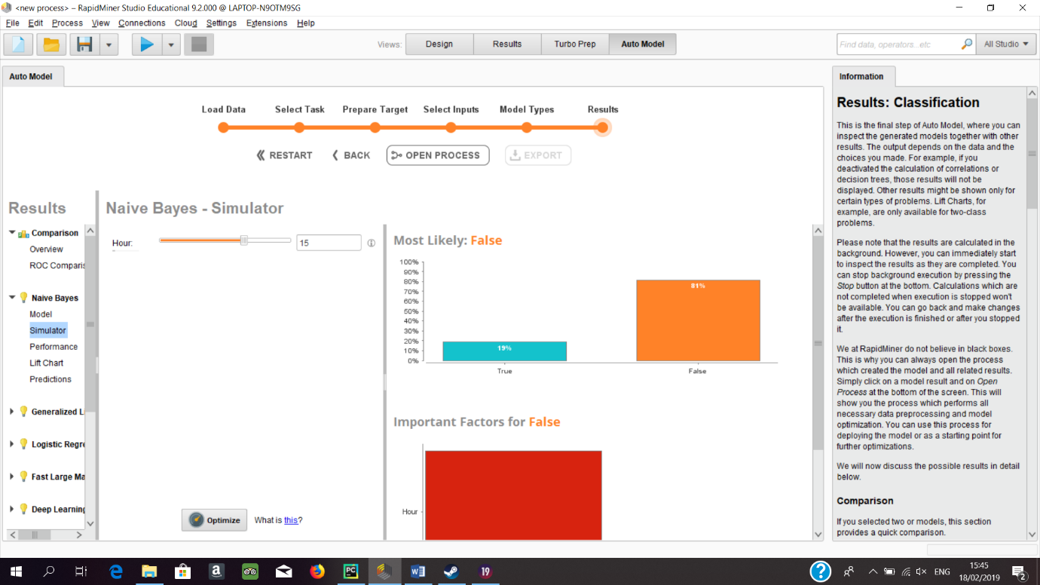 This screenshot shows the results of Naïve Bayes prediction of the probability of a crime being a felony crime if the time of day is 3pm. The result is 19% chance of the crime

being a felony crime.

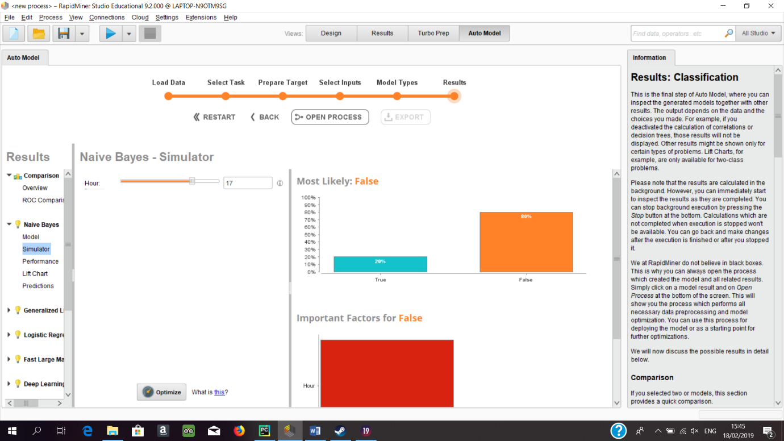 This screenshot shows the results of Naïve Bayes prediction of the probability of a crime being a felony crime if the time of day is 5pm. The result is 20% chance of the crime

being a felony crime.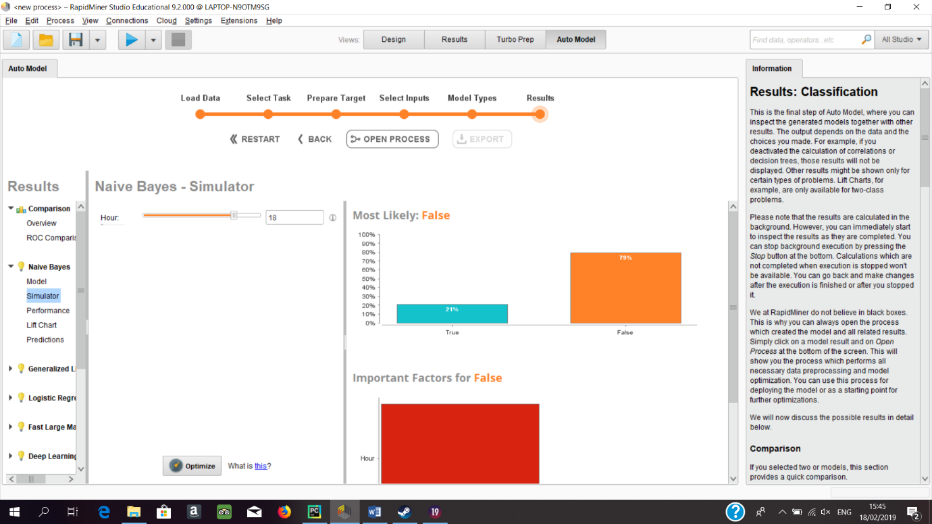 This screenshot shows the results of Naïve Bayes prediction of the probability of a crime being a felony crime if the time of day is 6pm. The result is 21% chance of the crime

being a felony crime.

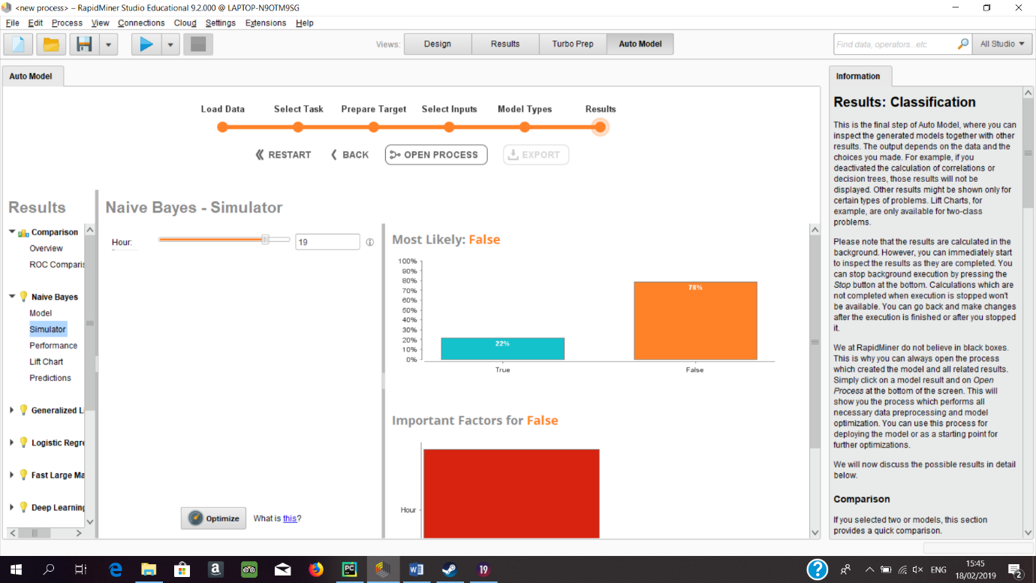

This screenshot shows the results of Naïve Bayes prediction of the probability of a crime being a felony crime if the time of day is 7pm. The result is 22% chance of the crime

being a felony crime.

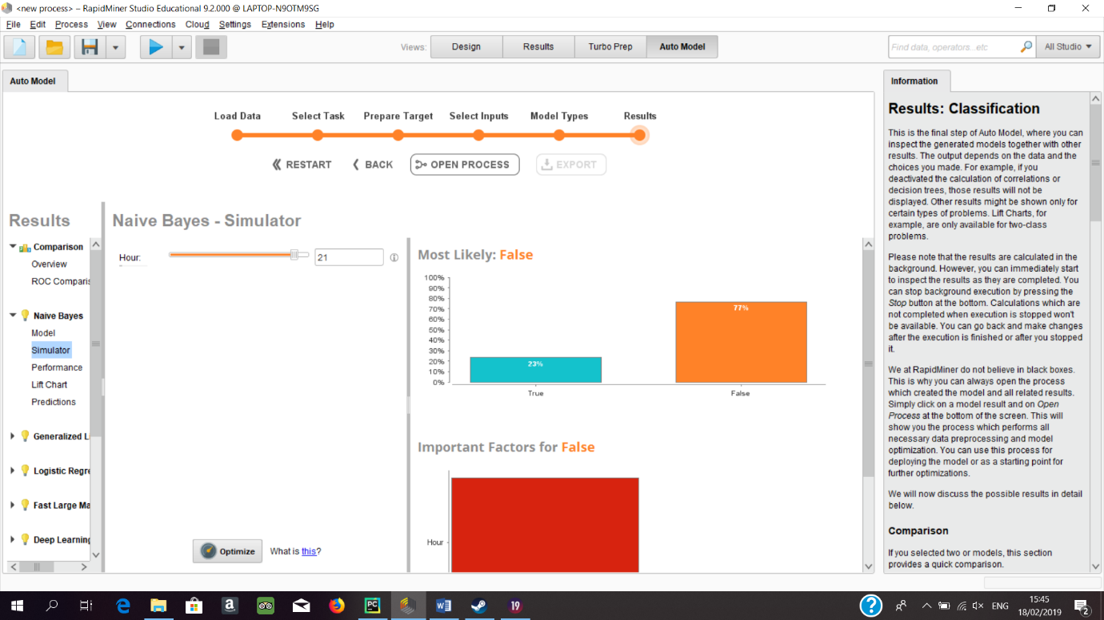 This screenshot shows the results of Naïve Bayes prediction of the probability of a crime being a felony crime if the time of day is 9pm. The result is 23% chance of the crime

being a felony crime.

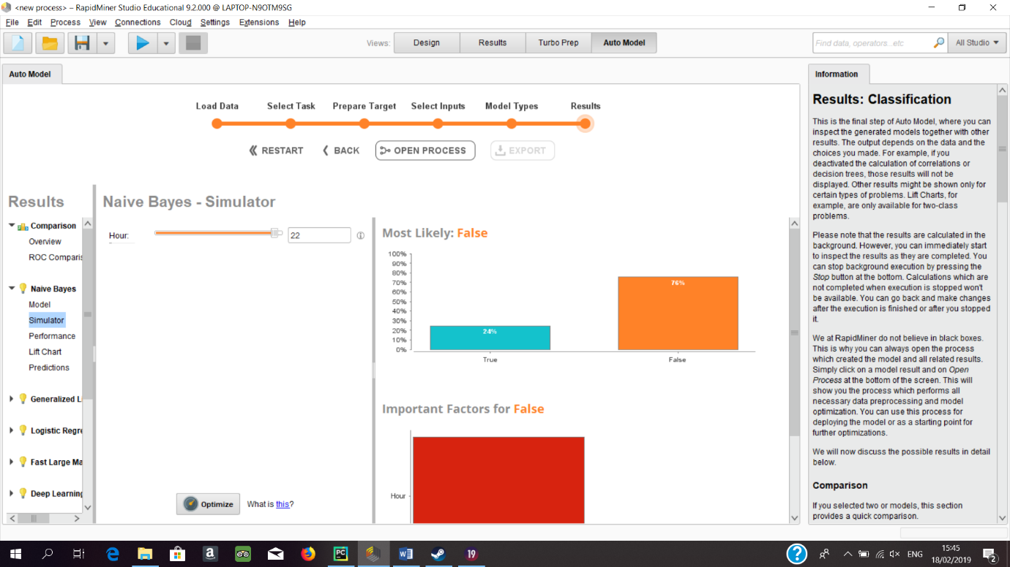 This screenshot shows the results of Naïve Bayes prediction of the probability of a crime being a felony crime if the time of day is 10pm. The result is 24% chance of the crime

being a felony crime.

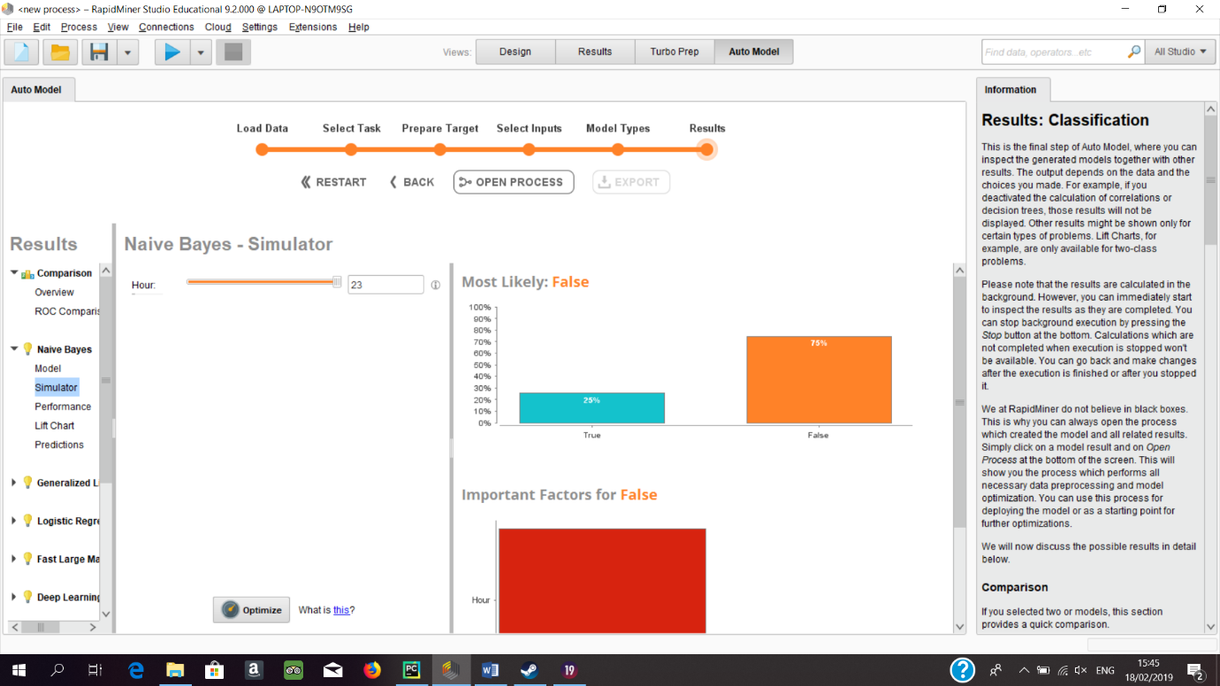 This screenshot shows the results of Naïve Bayes prediction of the probability of a crime being a felony crime if the time of day is 11pm. The result is 25% chance of the crime

being a felony crime.

**Assessment:**

Assuming the day begins at 12 midnight, the probability of an arrest being for a felony crime increases consistently throughout the day. Beginning at midnight with a probability of 14%, this continues to grow until the end of the day at 11pm which yields a probability of 25%.

The histogram somewhat correlates with these findings as the histogram displays an increase of crime from 2am up until 11am where the amount of crime levels off. There is some discrepancies at this point between the amount of crime vs the probability of felony especially when comparing 3pm with 11pm but of course this could be based off fact and is exactly the kind of anomaly that was being searched for. For this reason it will be assumed that this is accurate.

A point of interest in the results is the difference between 12am and 11pm but the histogram actually supports this by displaying the massive decline in arrests rate at 12am.

The model was calculated to have an 81% accuracy.

**Recommendations:**

Thankfully for this section there is more information to be gleaned from the results. This information is however very straight forward. The morning times are the safest for the people who are living in these densely populated areas. As the day continues smaller crimes begin to become more frequent. The total amount of crime begins to drop off a bit in the evening time. This is however when the rate of felony crimes begins to rise to almost 1 in 4 until it actually becomes 1 in 4 at 11pm at night. It would be highly recommended that people avoid these areas between the hours of 5pm and 11pm. These hours are extremely dangerous times.

Furthermore it is naturally recommended that the police increase their policing of these areas between 5pm and 11pm.

**Total Analysis of Baltimore Crime**

**Objective:**

The objective of this section is to analyse the data and try to find anomalies in the data. An example being the highest percentage of probability that a crime is a felony. This is primarily an exercise to utilise the data to display extreme statistics.

**Data:**

The data used for this section is the finaldata and LowIncomeDenseAreas datasets. The reason for using the LowIncomeDenseAreas dataset is because there were higher results in both studies regarding the probability of felony crime when focusing on low income and high density areas. It seemed logical that the result of the highest probability of felony crime would come from a high density, low income area.

**Modelling Technique:**

The modelling technique chosen here is Naïve Bayes. This was chosen as only one column is being used to predict the outcome of felony or misdemeanour. Naïve Bayes will be able to do this task with extreme ease.

**Results:**

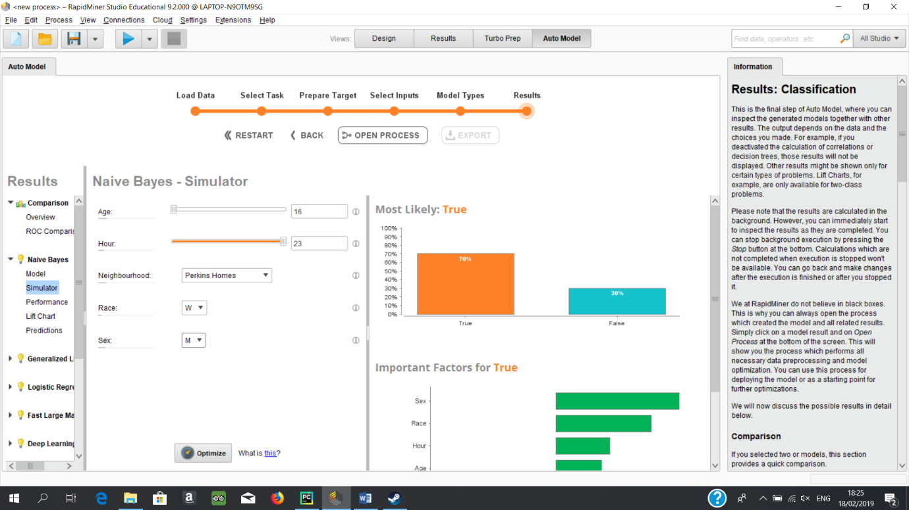 This screenshot shows the results of Naïve Bayes prediction of the probability of a crime being a felony crime if the age of the offender is 16, time of day is 11pm, Neighbourhood is Perkins Homes, Race is white and Sex is Male. The result is 70% chance of the crime

being a felony crime.

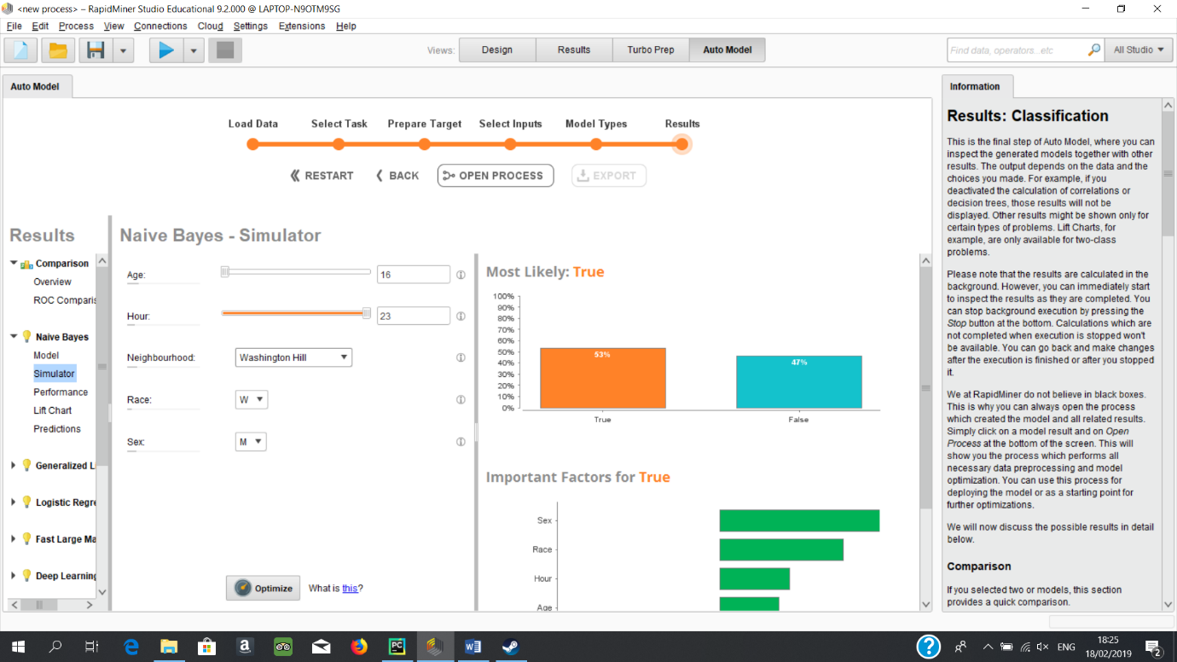

This screenshot shows the results of Naïve Bayes prediction of the probability of a crime being a felony crime if the age of the offender is 16, time of day is 11pm, Neighbourhood is Washington Hill, Race is white and Sex is Male. The result is 53% chance of the crime

being a felony crime.

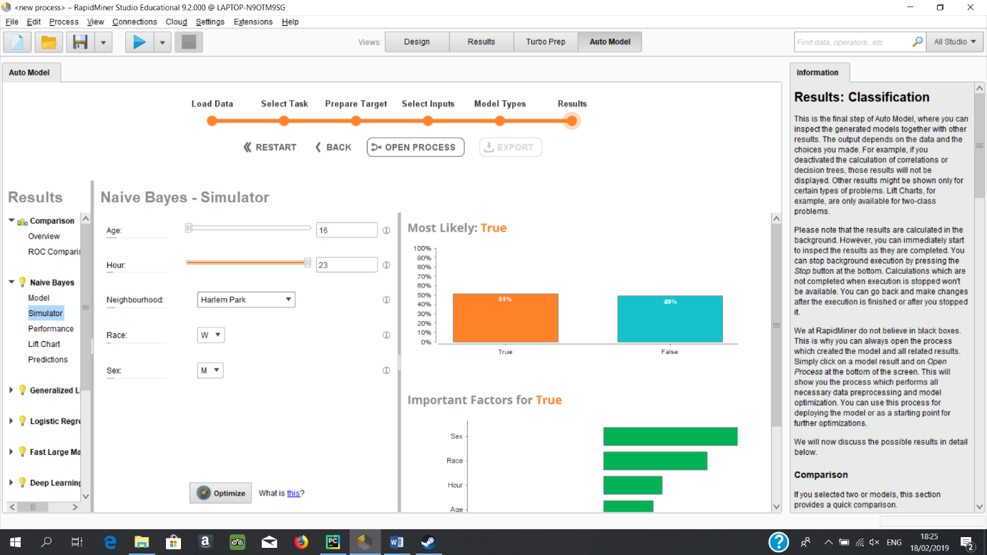 This screenshot shows the results of Naïve Bayes prediction of the probability of a crime being a felony crime if the age of the offender is 16, time of day is 11pm, Neighbourhood is Harlem Park, Race is white and Sex is Male. The result is 51% chance of the crime

being a felony crime.

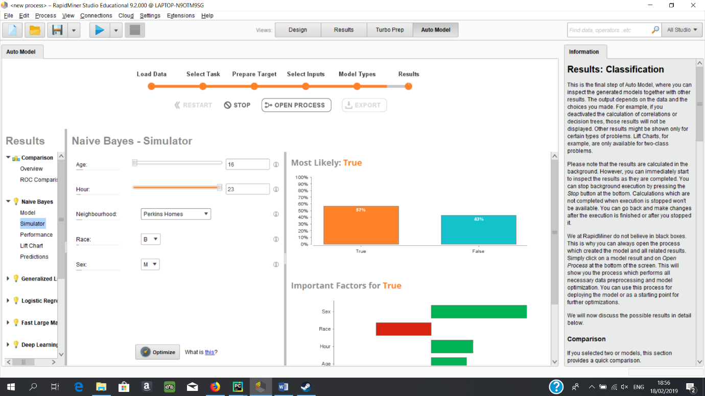 This screenshot shows the results of Naïve Bayes prediction of the probability of a crime being a felony crime if the age of the offender is 16, time of day is 11pm, Neighbourhood is Perkins Homes, Race is black and Sex is Male. The result is 57% chance of the crime

being a felony crime.

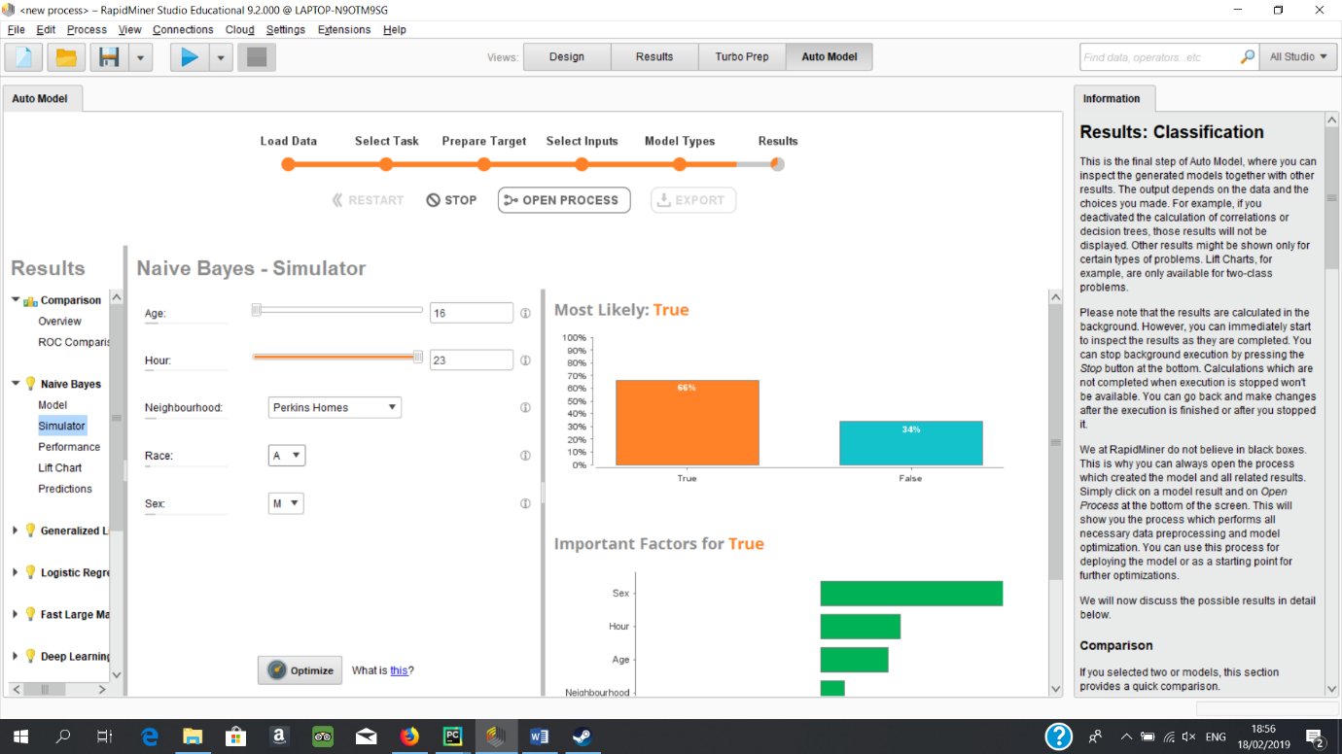 This screenshot shows the results of Naïve Bayes prediction of the probability of a crime being a felony crime if the age of the offender is 16, time of day is 11pm, Neighbourhood is Perkins Homes, Race is Asian and Sex is Male. The result is 66% chance of the crime

being a felony crime.

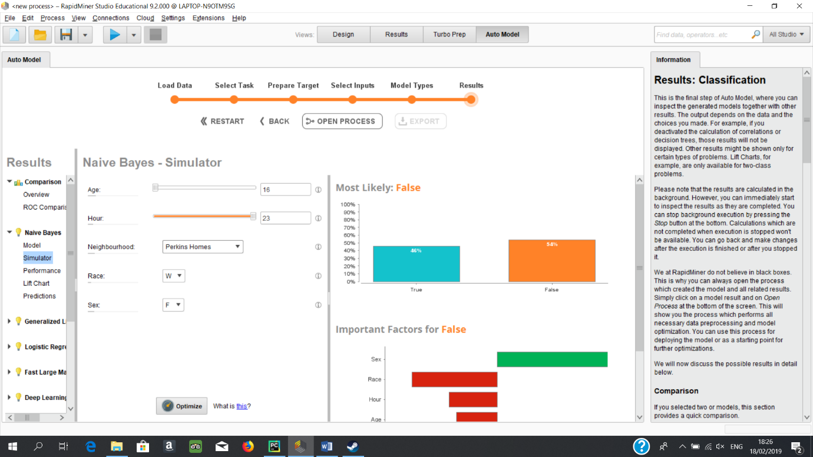

This screenshot shows the results of Naïve Bayes prediction of the probability of a crime being a felony crime if the age of the offender is 16, time of day is 11pm, Neighbourhood is Perkins Homes, Race is white and Sex is Female. The result is 46% chance of the crime

being a felony crime.

**Assessment:**

Having Assessed the results it was determined that age had a very high effect on the results. As a result all the highest results were at age 16. This was also true for the time as all the highest results were at 11pm at night.

The results were calculated and as shows it was white males aged 16 who committed crimes at 11pm at night in Perkins homes who had the highest probability of committing a felony with a 70 % chance.

As race and sex were untested areas these areas were tested further. Asian males aged 16 who committed crimes at 11pm in PerkinsHomes were 66% likely to commit felonys. Changing only the race to black resulted in a result of 57% which represented the highest result for that race. There was not enough instances of Hispanic felonies to result in a percentage probability.

The highest female result was white female aged 16 who committed crimes at 11pm in Perkins Homes.

**Recommendations:**

Truthfully having assessed these results and seen the remarkably high results for Perkins Homes I would recommend the police department begin a special task force in order to deal with the high levels of serious crime in Perkins Homes.

**Statistical Analysis of the Data**

**Objective:**

The objective of this section is to use python to create statistics and compare these statistics from some statistics gleaned from Infoplease.com about Baltimore.

**Data:**

The data used for this section is the DateAndHoursArrests dataset and the statistics gleaned from Infoplease.com.

**Modelling Technique:**

The modelling technique chosen here is Naïve Bayes. This was chosen as only one column is being used to predict the outcome of felony or misdemeanour. Naïve Bayes will be able to do this task with extreme ease.

**Referencing**

<https://nationalinterest.org/feature/why-police-cant-stop-crime-baltimore-34397>

<https://eu.usatoday.com/story/news/2018/09/25/baltimore-homicide-murder-rate-fbi-statistics-death-crime-killings/1426739002/>

https://baltimore.cbslocal.com/2018/10/17/baltimore-drug-turf-war-causing-crime-spike/